**DSD LAB 6**

1. Write behavioral Verilog code for a negative edge triggered T FF with asynchronous active

low reset.

module l6q2(t,clock,reset,q);

input t,clock,reset;

output q;

reg q;

always@ (negedge clock or negedge reset)

begin

if(!reset)

q<=0;

else

case(t)

0:q<=q;

1:q<=~q;

endcase

end

endmodule

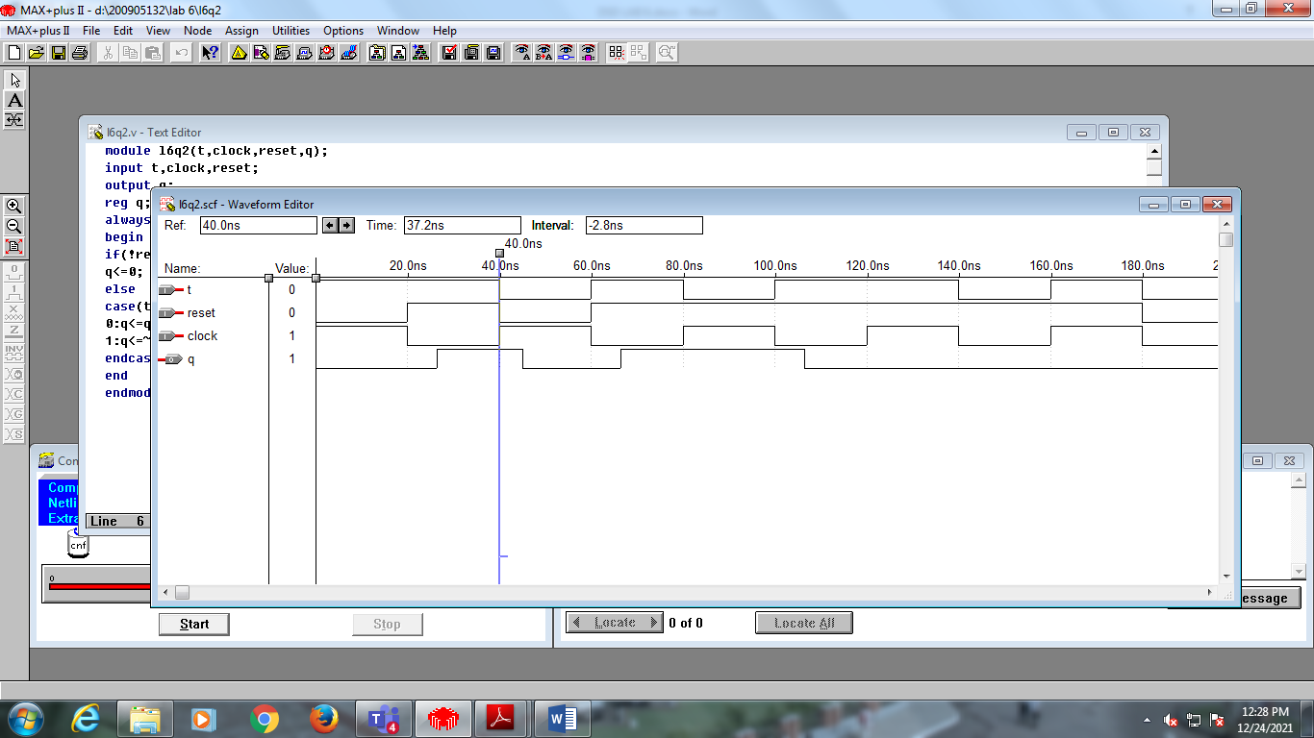

2. Write behavioral Verilog code for a positive edge-triggered JK FF with synchronous active

high reset.

module l6q1(j,k,clock,reset,q);

input j,k,clock,reset;

output q;

reg q;

always@ (posedge clock)

begin

if(reset)

q<=0;

else

case({j,k})

0:q<=q;

1:q<=0;

2:q<=1;

3:q<=~q;

endcase

end

endmodule

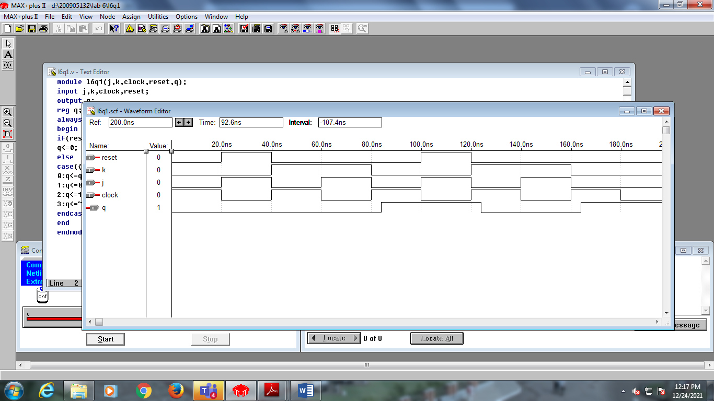

3. Design and simulate the following counters a) 4-bit ring counter. b) 5 bit Johnson counter.

a) bitcounter2 one(clk,count[1:0]);

d2to4 two(en,count[1:0],q[3:0]);

endmodule

module dff11(clk,d,q);

input clk,d;

output q;

reg q;

always@(posedge clk)

begin

q=d;

end

endmodule

module d2to4(en,w,y);

input en;

input [1:0]w;

output [3:0]y;

reg [3:0]y;

always@(en or w)

begin

y=0;

if(en==1)

case(w)

0:y[3]=1;

1:y[2]=1;

2:y[1]=1;

3:y[0]=1;

endcase

end

endmodule

module bitcounter2(clk,q);

input clk;

output[1:0]q;

dff11 ffo(clk,q[1]^q[0],q[1]);

dff11 ff1(clk,~q[0],q[0]);

endmodule

b) module l6q32(clock,q);

input clock;

output [4:0]q;

reg [4:0]q;

integer k;

always@ (posedge clock)

begin

for(k=0;k<4;k=k+1)

q[k]<=q[k+1];

q[4]<=~q[0];

end

endmodule

module johnson(clk,q);

input clk;

output [4:0]q;

dff1 ffo(clk,~q[4],q[0]);

dff1 ff1(clk,q[0],q[1]);

dff1 ff2(clk,q[1],q[2]);

dff1 ff3(clk,q[2],q[3]);

dff1 ff4(clk,q[3],q[4]);

endmodule

module dff1(clk,d,q);

input clk,d;

output q;

reg q;

always@(posedge clk)

begin

q=d;

end

endmodule

